Help us Honor Randolph’s Hometown Heroes by sponsoring a Photo Banner for Veteran’s Park

Randolph VFW Post 7333 and Felicia Smith have formed a Committee to display large photo banners to honor our local Veterans. Each banner will feature the Veteran’s name and branch of service and years of service. The banners will be installed on the light poles at the new Veteran’s Community Park on Calais Road. The banners will be hung for 9 months and then renewed or replaced.

We are asking for sponsors to help fund this program. Businesses as well as families are welcome to participate. Each sponsorship is $95 to pay for the printing of a banner. The installation will be provided by Randolph Township. The sponsor’s name will be shown on the banner and will be publicized in social media and other marketing efforts.
Donations toward the program are also accepted and will be recognized.
For questions contact Bill Menzel at 973.945.8507 or email smithfelicia103@gmail.com.

If a specific veteran is being honored the sponsor must complete and return the attached BANNER DESIGN form along with a photo.

Number of Banners you would like to sponsor: ________
Donation you would like to make: $_______________
Total amount enclosed: $_________

Business/ Family Name (as it should appear on the banner): (Print please)

____________________________________________________________________________

Contact Name: ________________________________________________________________

Email address: ________________________________________________________________

Street Address: _______________________________________________________________

City, State, Zip Code: __________________________________________________________

Phone number: _______________________________________________________________

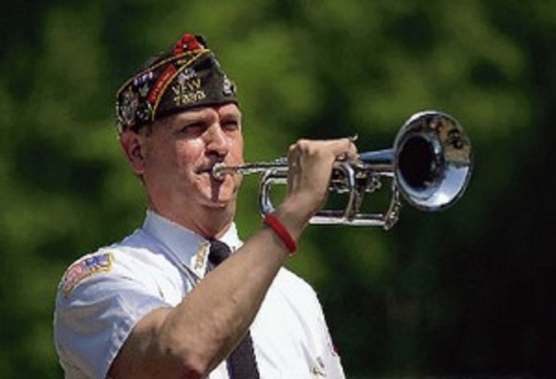
Please return this form with payment to:

Randolph VFW Post 7333
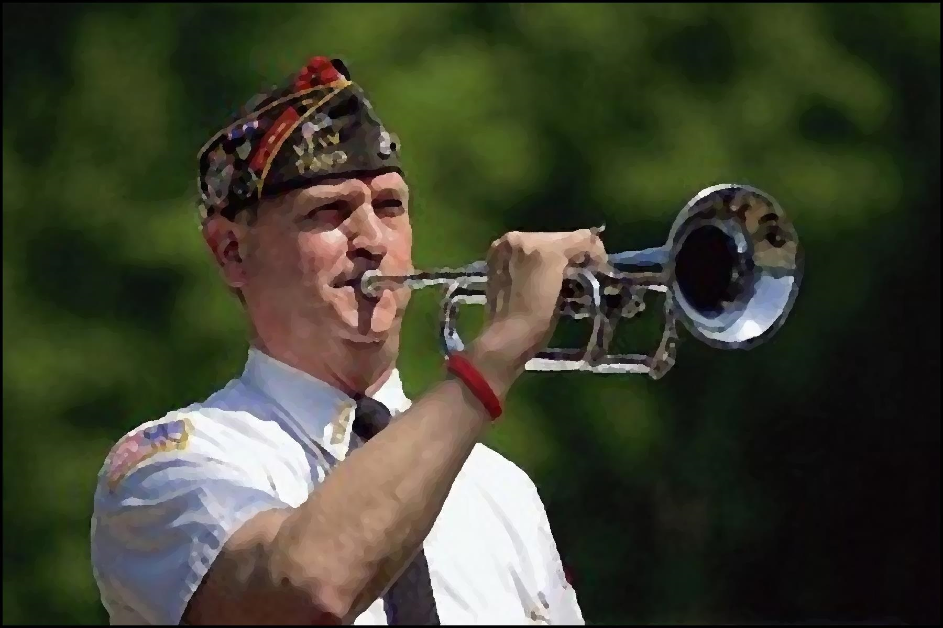103 Carrell Road
Randolph, NJ 07869
Hometown Hero Banners
Attention: Bill Menzel

